WEB TECHNOLOGIES 1
Assignment #4: Introduction to JavaScript
KFC Bosses | KFC Kazakhstan Fan Project | Group SE-2510
Team: Zharkyn Akhmetov · Alnur Bakbergenov · Khantore Orynbassar
Deployed website URL: WEB-1 Assignment 4

1. Objective
The objective was to extend an existing multi-page KFC-themed educational website with five interactive JavaScript features: form validation, a FAQ accordion, a subscription popup, dynamic background colors, and a live date/time display. The project is a student fan website, not an official KFC service.

2. Project Overview
The project includes seven pages: Main Menu, Food Menu, Special Offers, Our Team, Location & Schedule, Reviews & Feedback, and Gallery. The pages share JavaScript and CSS assets. All team members are listed in the footer. Each team member must be able to explain the implementation during the defense.
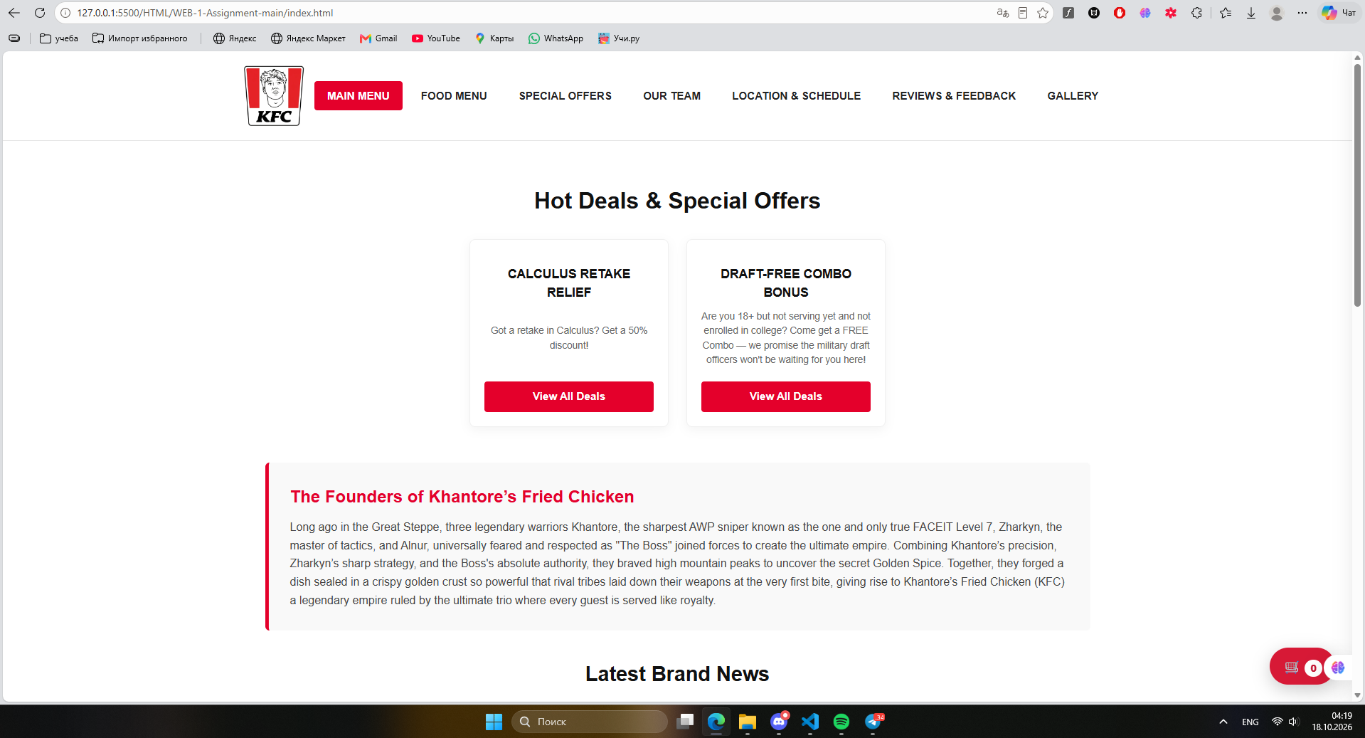
Figure 1. Main page showing the existing website design and navigation.

3. Task 1: Form Validation (15%)
Page: contacts.html. The review form requires a name, valid email, review text, a password of at least eight characters, and matching password confirmation. Errors are displayed without reloading the page. A valid submission adds a review to the visible feed and updates the review summary. Passwords and email addresses are not saved in the local review records.
- Create the review form with required fields and a visible validation-message element.
- Intercept the submit event with preventDefault() and read the form values.
- Check required values, email validity, password length, and matching confirmation.
- Display an error for invalid input; otherwise add the review, refresh the feed, and show success feedback.
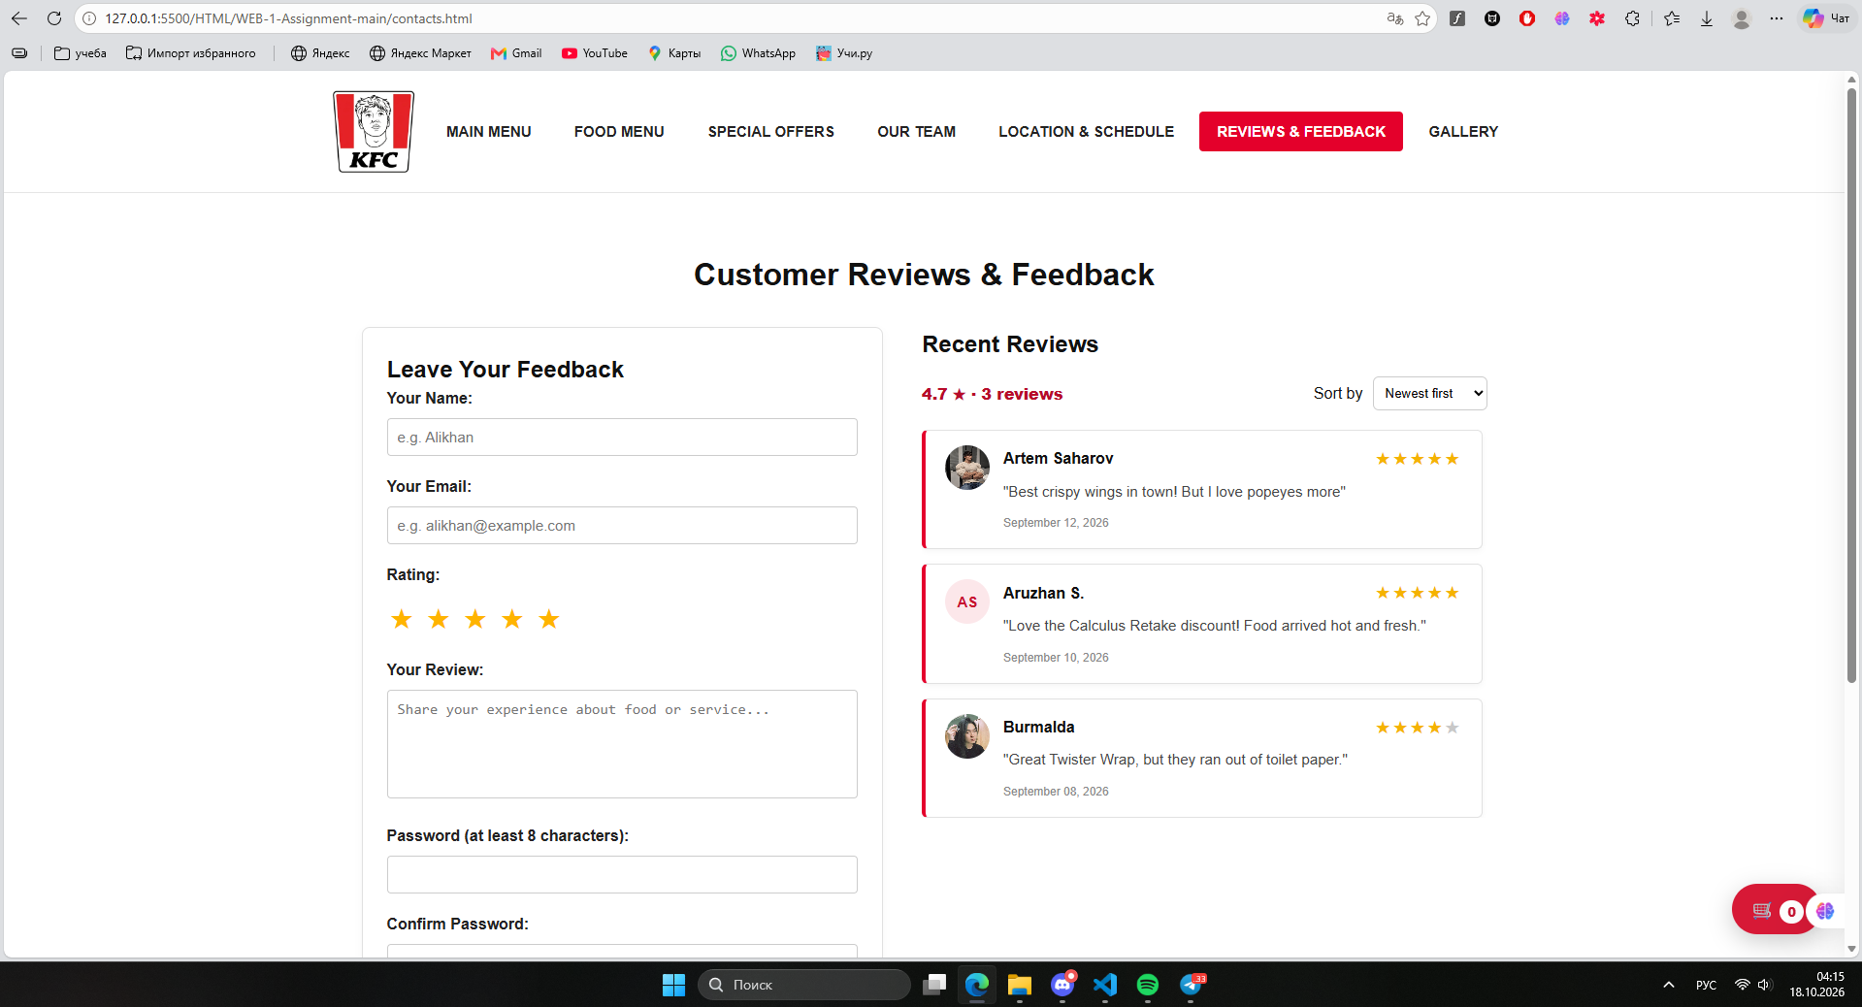
Figure 2. Review form before submission.
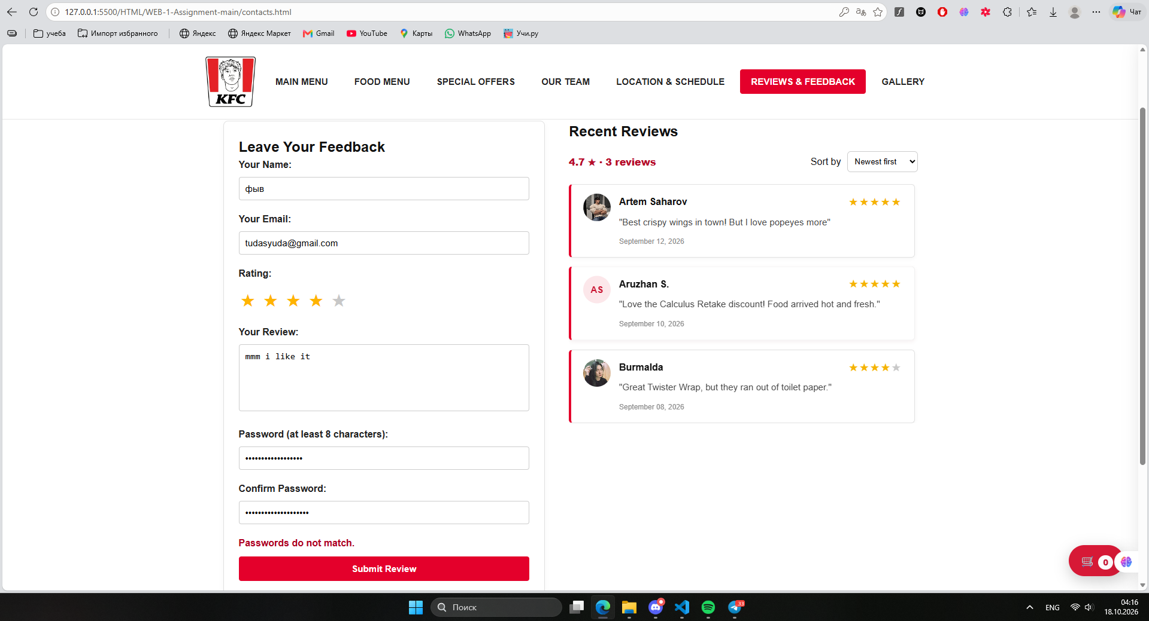
Figure 3. Validation error when the two passwords do not match.
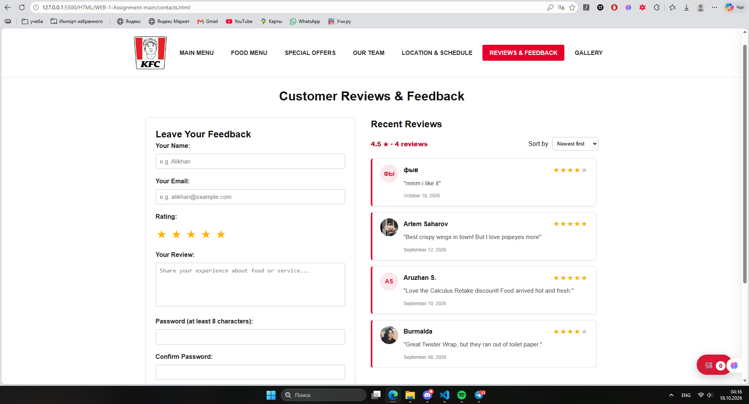
Figure 4. Successful submission: the new review appears and the average rating updates.

4. Task 2: FAQ Accordion (15%)
Page: index.html. Questions start collapsed. Clicking a question toggles its answer using JavaScript and CSS transition classes. The selected question changes its plus/minus indicator and aria-expanded state; opening a different question closes the previous one.
- Create question buttons and answer containers.
- Attach click handlers to update aria-expanded and toggle the is-open class.
- Collapse other answers and rely on CSS transitions for smooth opening/closing.
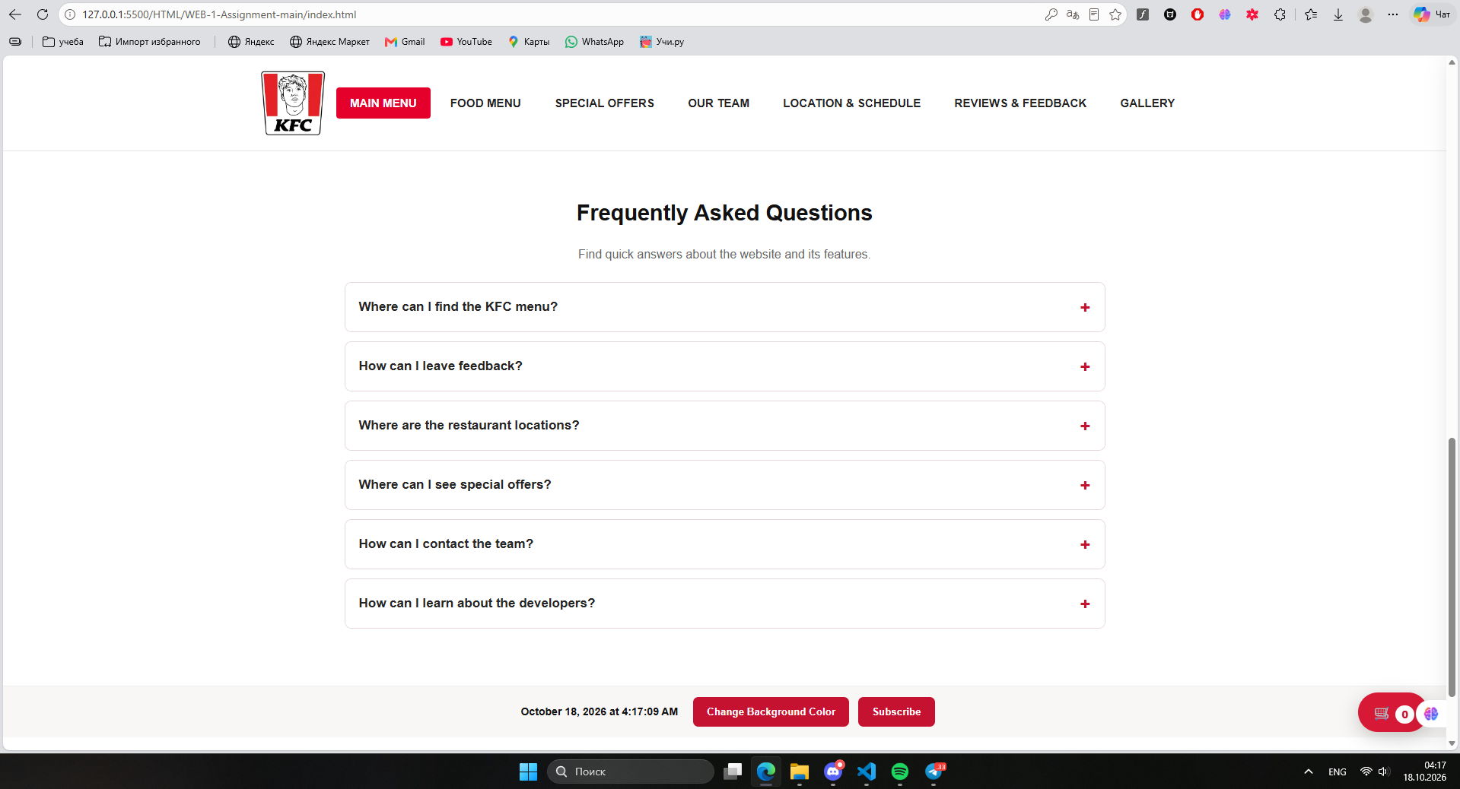
Figure 5. FAQ answers hidden by default.
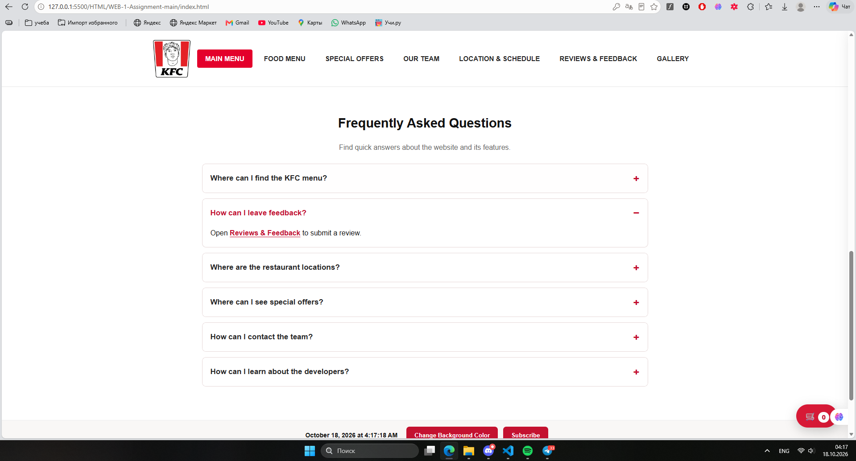
Figure 6. A FAQ answer revealed after clicking its question.

5. Task 3: Subscription Popup (10%)
The Subscribe button opens a hidden modal with Name and Email fields. JavaScript controls visibility and focus. The popup supports closing by the X button, backdrop click, or Escape key. Submission checks required fields and email format, then displays a demo-only success message.
- Add the hidden modal and Subscribe trigger button to the pages.
- Open the dialog on click and return focus when it closes.
- Handle X, backdrop, and Escape actions.
- Validate the two fields and display clear feedback.
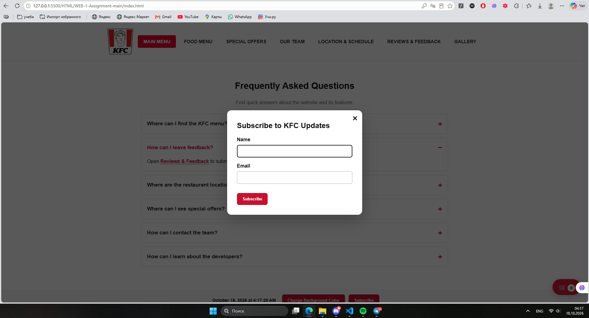
Figure 7. Subscription form displayed as a popup.
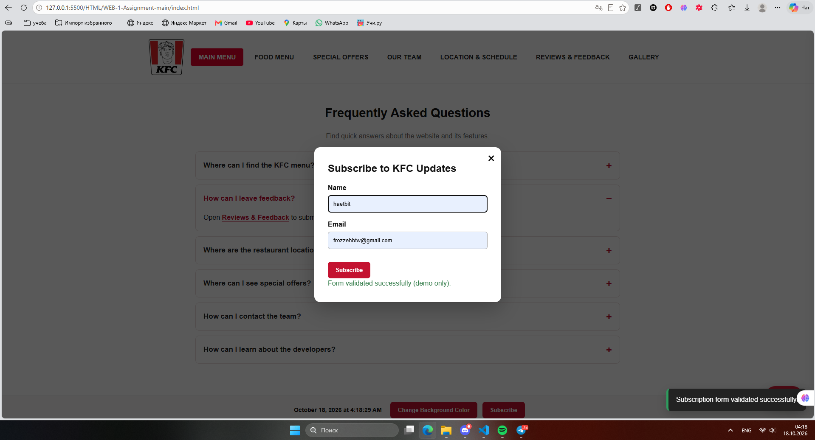
Figure 8. Valid subscription input and success feedback.

6. Task 4: Change Background Color (5%)
The Change Background Color button cycles through five predefined colors. On each click, JavaScript advances a color index and assigns the selected value to document.body.style.backgroundColor.
- Add a button with a unique ID.
- Define an array of background colors and track the active index.
- Update the body background color in the button click handler.
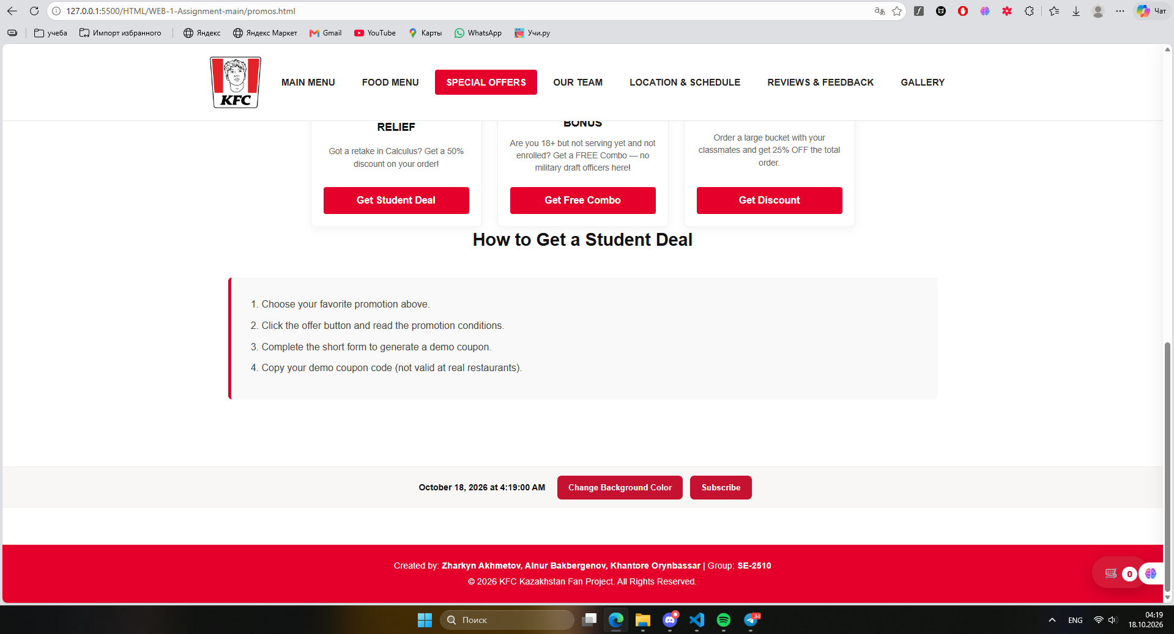
Figure 9. Page before changing the background color.
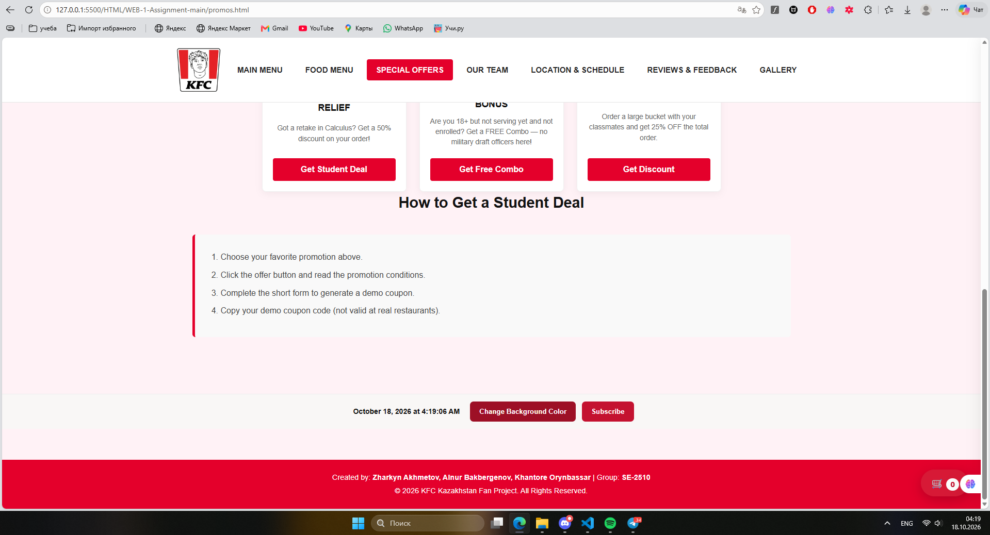
Figure 10. Page after changing the background color to light pink.

7. Task 5: Current Date and Time (5%)
A shared toolbar displays the current date and time. JavaScript creates a Date object, formats it with toLocaleString(), and refreshes the text once per second using setInterval(). The clock is visible in Figures 5, 9, and 10 at different times.
- Add a live-clock element to the shared toolbar.
- Format the current date/time in a readable English format.
- Refresh the displayed value every 1,000 milliseconds.

8. Additional Interactive Features
Beyond the five required tasks, the project includes a food customization modal, a demo shopping cart, developer profile dialogs, gallery lightbox navigation, star ratings, review sorting, student promotion coupon dialogs, and smooth scrolling on the Special Offers page. These features supplement the required Assignment 4 components.

9. Testing and Results
The supplied browser screenshots demonstrate an invalid password-confirmation error, successful review insertion, collapsed and expanded FAQ states, a visible subscription popup with success feedback, two background colors, and a changing clock. These observations support the five core tasks. Cross-browser/mobile testing and a final console-error check should still be completed before submission.

10. Deployment and Collaboration
The updated project must be pushed to the shared repository and published through GitHub Pages or Netlify. Replace the deployment URL placeholder on the first page with the public URL before submission. The report and complete project ZIP must both be submitted. Each member is responsible for understanding the components and demonstrating them during the practice lesson.

11. Conclusion
The project shows how JavaScript turns static pages into an interactive website through validation, expandable content, modal dialogs, dynamic styling, and live time updates. The provided screenshots document the implemented features and their visible results.

